**Literature Survey for**

**( SmartFarmer - IoT Enabled Smart Farming Application )**

**ABSTRACT:**

Since a few years, smart devices have become an integral part of our daily lives. As a result, on smart devices, offering facilities and security is becoming more important. The goal of this Project is to create a **Smart Farming system** that works with Android mobile devices. IOT allows the mobile device and the system to communicate with one another through **Node MCU, IBM Cloud, Node RED application and Raspberry pi**. Current studies discusses the IoT-Based Smart Farming System. Any suitable device may load the mobile application and interact with the system. Commands to turn on/off electrical equipment such as Motor, Light, and Motorized ball valve, as well as setting timers, can be delivered simply and fast from mobile devices through a simple and pleasant GUI application that is straightforward to use for any average user. The system then acts and responds to these orders by performing the tasks specified in the commands and informing the user of the outcome. At any place in the world, the user may also view the result on an Android mobile application. As a result, developing a Smart Farming system to reduce workload for farmers that strives to create an advanced Smart Farmer system utilizing Wi-Fi technology, Cloud and Node RED as a solid option.

**APP LOGO**



**INTRODUCTION:**

Technological improvements and innovations are commonplace in today's society, and people's living standards are rising as well. People's lives have been inspired by mobile phones in recent years. In recent years, the mobile phone has emerged as the most important aspect of people's lives. Humans can conduct a range of jobs, both on and off the internet, with the help of these smart gadgets, like as make our homes and companies smarter and more elegant. We demonstrated a method for **connecting and controlling electric devices like Motor, Light, and Motorized ball valve using an Android mobile app and a Wi-Fi module with help of Node MCU, IBM Cloud, Node RED and Raspberry pi**. To communicate the data given by the apps, the Wi-Fi transmitter employs radio waves. Wi-Fi data is converted into an electronic signals, which is then sent via the antenna; Wi-Fi is based on radios signals technology. This signal is sent to the Controller. The data is then manipulated and operations are performed by the Raspberry pi. This controllers may be connected to the Relaying terminals of different switches to transfer the current after producing the magnetic field.

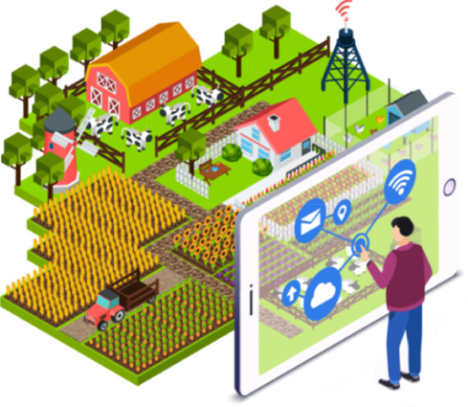

The system's reliability may be ensured by adding new appliances at any time. Smart Farming is particularly significant in today's world because of its ability to be used in a variety of locations with great accuracy, saving money and time by reducing human effort. The primary goal of this technology is to automate the control of domestic appliances such as Motor, Light, and Motorized ball valve. This literature survey goes into great depth on Smartand security systems that use Raspberry pi and GSM, as well as how we can manage Farming applications using an Android application. When a person enters the home, the number of people entering the house is increased, and in Home Automation mode, appliances are switched on, but in Security Mode, the security light is tuned on along with the alert. On the LCD panel, the number of people who have entered the residence is also shown. When the room becomes empty, i.e., the number of people in the room drops to zero, the appliances are shut off, making the system more energy efficient. Furthermore, a person may operate his home appliances using an android application on his phone, reducing the amount of manual labor required. Simultaneously, if someone enters when security mode is activated, an SMS would be sent to the home owner's phone, indicating the presence inside the house. The alarm may be turned off by sending a text message or using an Android app.